Front Door Creation: -
For static web storage creation URL
https://dev.to/droz79/how-to-host-a-static-website-in-azure-blob-storage-4jc8#:~:text=HOW%20TO%20HOST%20A%20STATIC%20WEBSITE%20IN%20AZURE,Storage%20...%205%

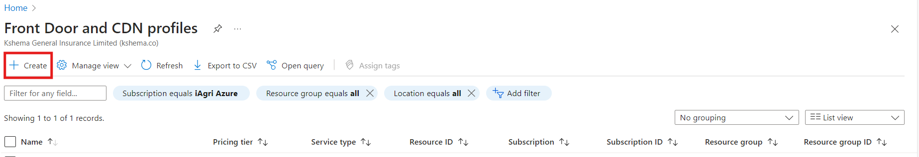

Create in Azure CDN Standard Classic for storage Blob static application with tls certification
First, we have created azure storage account.
Introduction
A static website is a type of website that is composed of HTML, CSS, JavaScript, images, and other static files. Unlike dynamic websites, which generate content on the server side in response to user requests, static websites deliver pre-built content to users exactly as it's stored. This means that every visitor to a static website receives the same content, regardless of their interactions with the site.
Static websites are typically used for simple websites with fixed content, such as personal blogs, company brochures, portfolios, or landing pages. They are easy to set up, fast to load, and require minimal maintenance compared to dynamic websites. Hosting a static website is often more cost-effective and straightforward, making it an attractive option for many individuals and businesses looking to establish an online presence.

Create storage account for static web

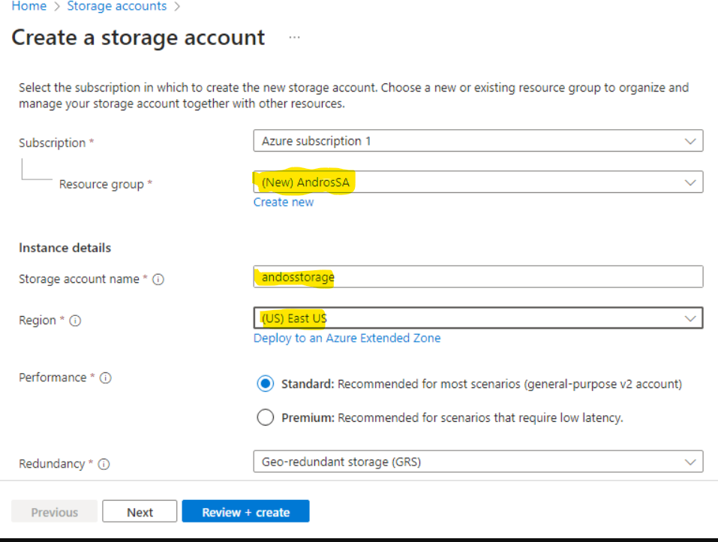

2. Enable the static website.
- In the left-hand menu of your storage account, under "Settings", select "Static website".
- Click on "Enabled" to enable static website hosting.
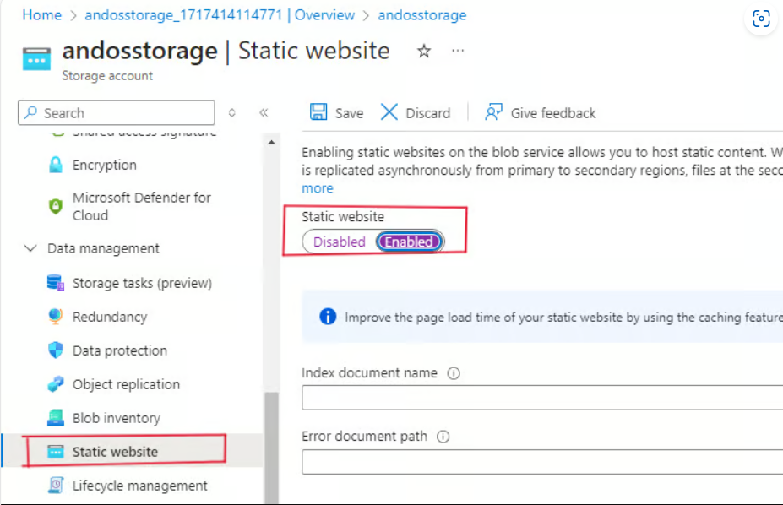
3. Set the index document name (usually "index.html") and optionally set the error document path (usually "error.html") if you have one.
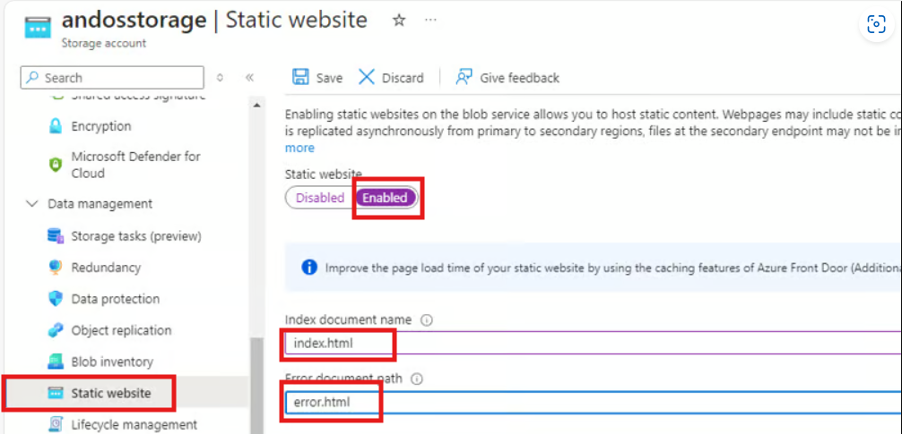

- Click "Save" to save the configuration.
- Once it's saved, primary and secondary endpoints are generated.
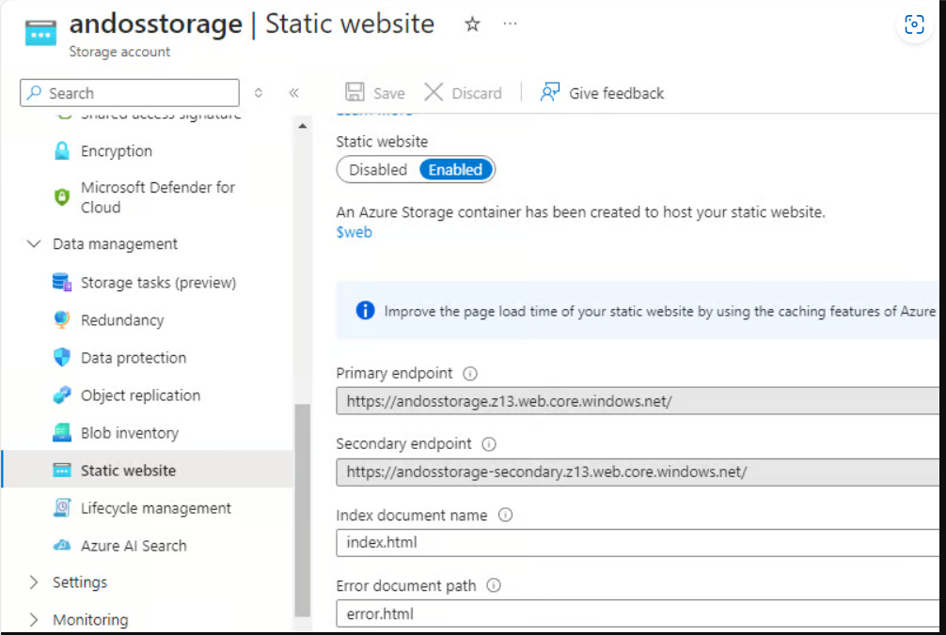
5.Go back to your storage account, click on containers, you can see th at a web container has been created to host your static website data.
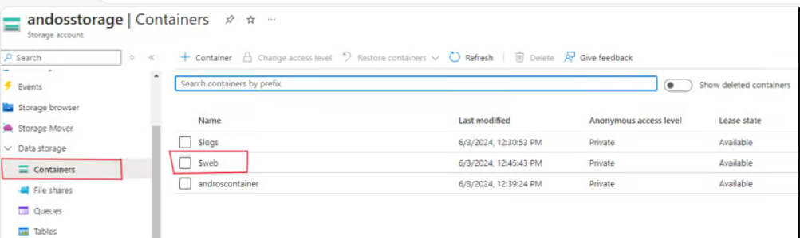

Once the files are uploaded, go back to the Azure portal and navigate to your Storage Account.
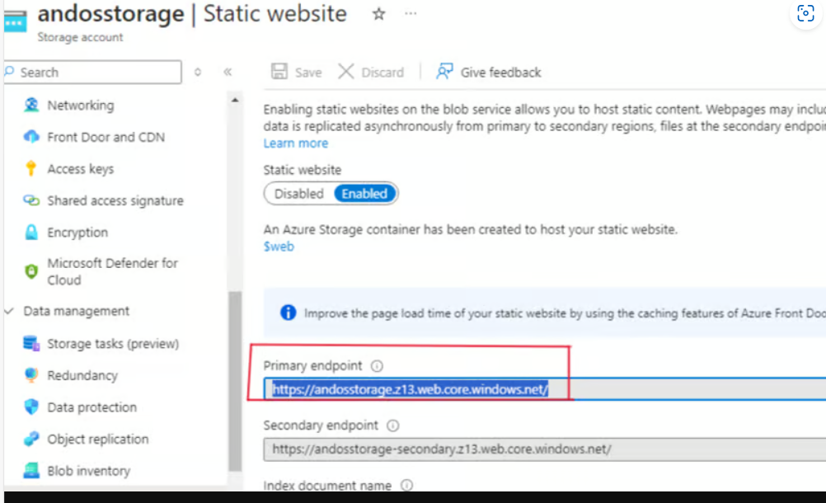

1.
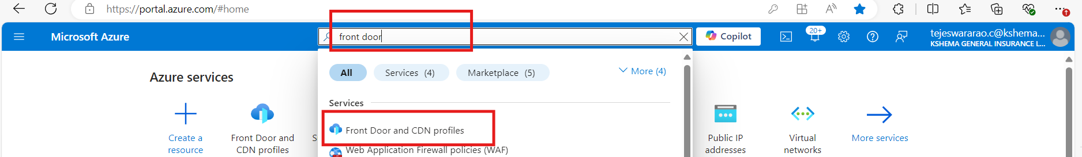

2.
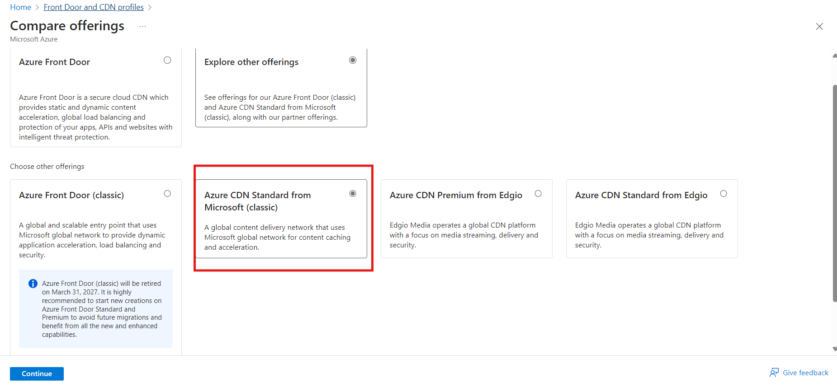

3.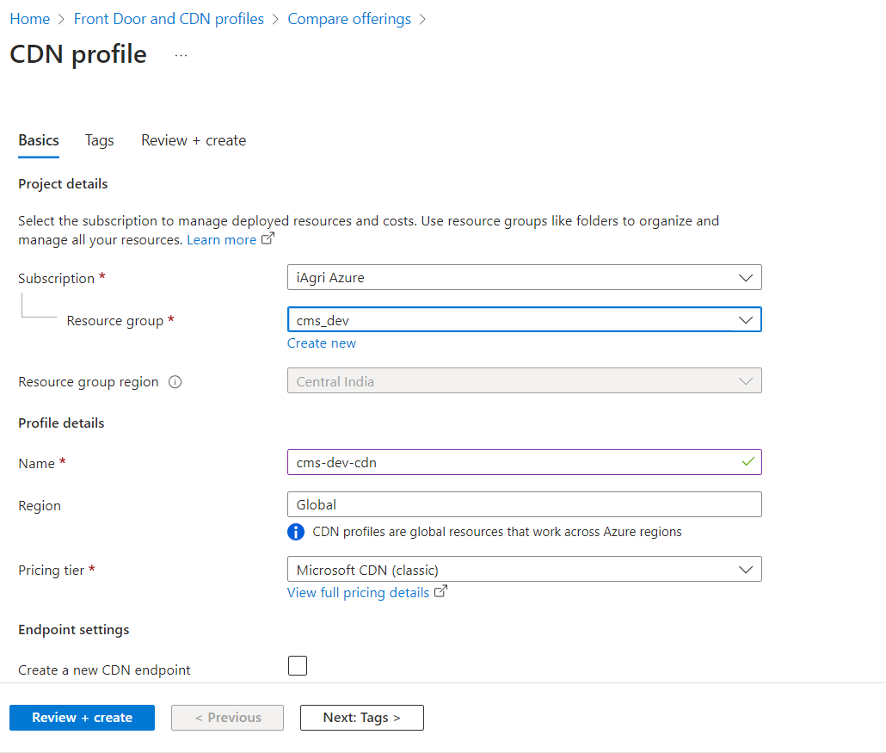

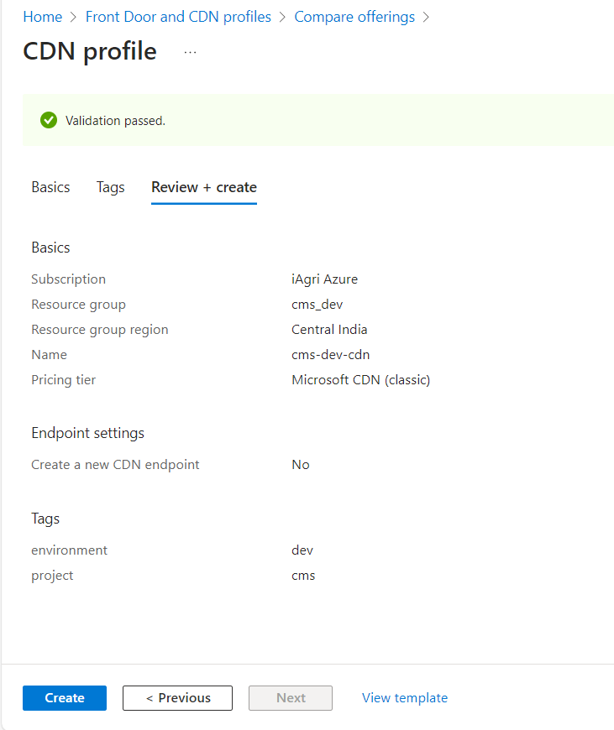

We add below details in endpoint as below.
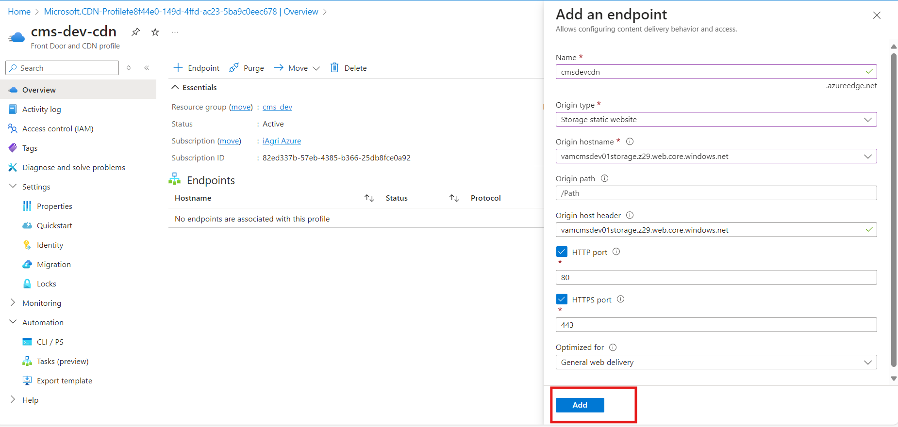
Add .
Update Origin and save.
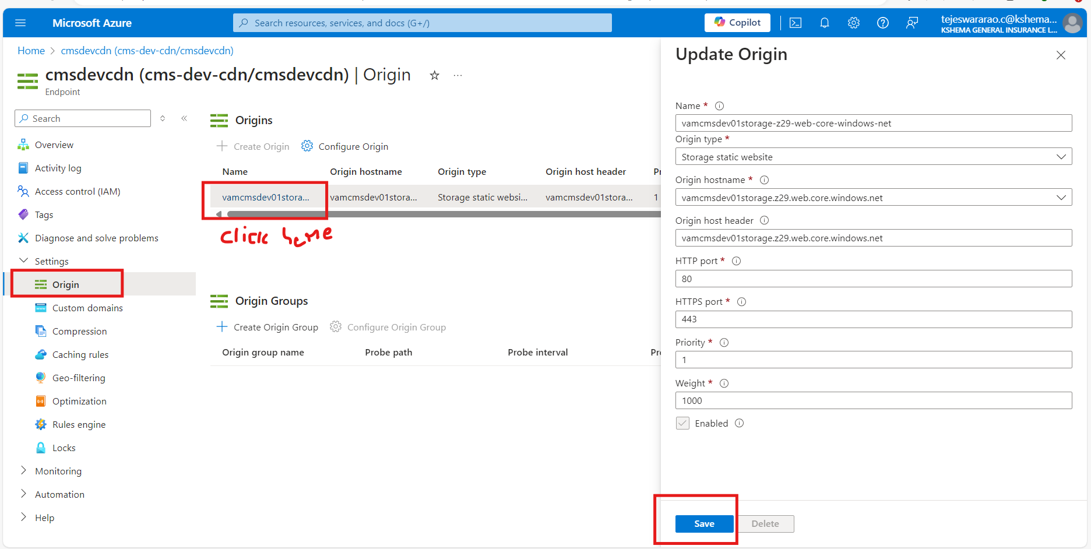
Create custom domain here we need to add our custom domain name and add
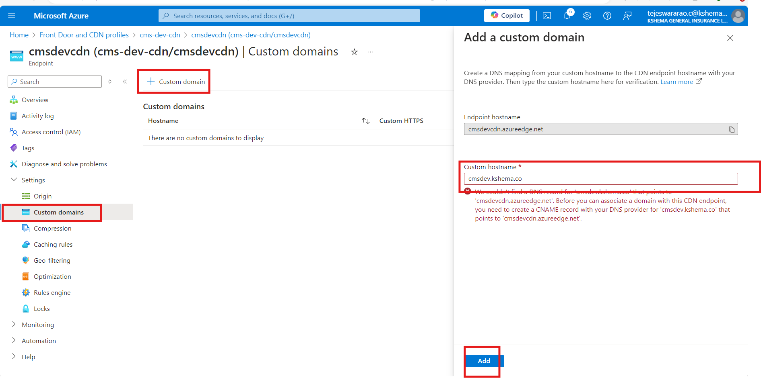

For https access we have to configure as showin in below click on domain and follow the below

